MILLENNIUM  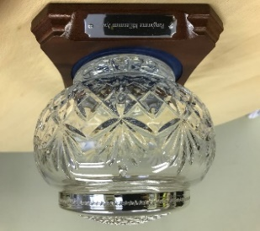  AWARD  2023 | DO YOU KNOW OF AN UNSUNG HERO IN PANGBOURNE ?  SOMEONE WHO VOLUNTEERS TIRELESSLY OR GOES THE EXTRA MILE  TO HELP OTHERS OR DELIVER PROJECTS?  SOMEONE WHO SUPPORTS YOUTH SERVICES , SPORTS CLUBS AND FACILITIES, ADULT SOCIAL CARE, PLAYGROUP , CHURCH GROUPS ,SCHOOL SERVICES OR RUNS A CLUB OR SOCIETY?  HAS ANYONE DRIVEN A PROJECT OR RUN A CAMPAIGN TO IMPROVE THE VILLAGE OR LOCAL AREA?  IF SO THEY DESERVE YOUR VOTE

Pangbourne Parish Council are pleased to be able to announce that nominations are once again open for the Millennium Award. The winner of the 2023 award will be presented with the Award Bowl at the Annual Parish Meeting on Thursday 18th May 2023
The Millennium Award is awarded to a variety of groups and individuals, in recognition of their contribution to the village, either through their work or voluntary activities. No one individual or group is allowed to win for a second time.
Please fill in the nomination form below and post / drop it in to the Parish Office at the Village Hall , Attn Clerk, Pangbourne Parish Council, Parish Office, Pangbourne Village Hall , Pangbourne RG8 7AN or email the Parish Council on Clerk@pangbourne-pc.gov.uk to arrive no later than Friday 14th April 2023
- -----------------------------------------------------------------------------------
MILLENNIUM AWARD
I would like to nominate:____________________________________________________________________________

Contact information of nominee (if known)_____________________________________________________________
I feel that they should be given the Pangbourne Millennium Award because: _______________________________________________________________________________________________________________________________________________________________________________________

My Name is :__________________________________________________________________________
(It is not essential to give your own name if you would rather not)

