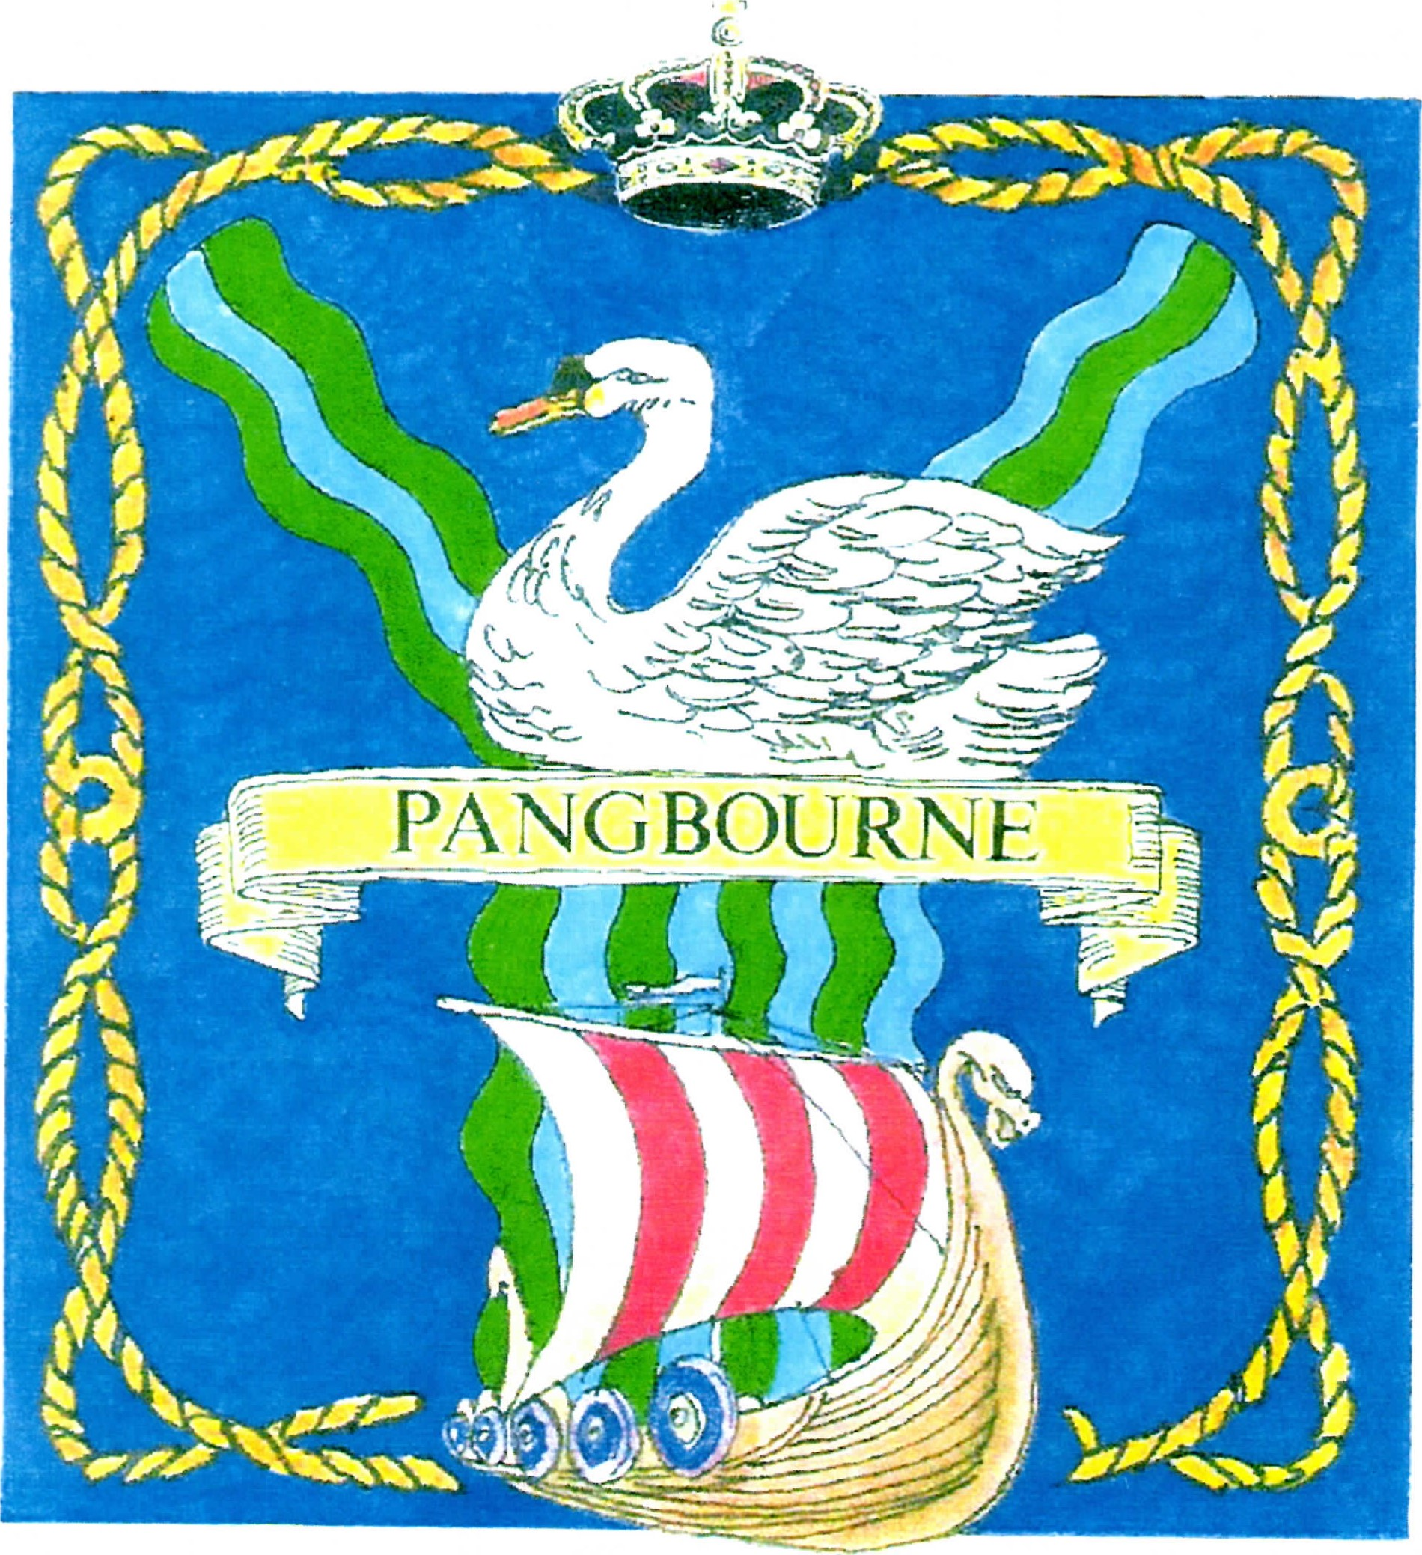

Pangbourne Parish Council

Parish Office, Pangbourne Village Hall, Station Road,
Pangbourne, Berks RG8 7AN Telephone: 0118 984 1118

Email: Clerk@Pangbourne-pc.gov.uk Website : www.Pangbourne-pc.gov.uk
utumn 2017
Autumn 2017
__________________________________________

NOTICE OF VACANCY
FOR COUNCILLOR

NOTICE IS HEREBY GIVEN

Two Casual Vacancies have arisen on Pangbourne Parish Council due to the resignations of Cllr C. Hartley and S.Ferguson .

A by-election to fill the vacancy will be held if, within 14 days (not counting a Saturday or Sunday, Christmas Eve, Christmas Day, Good Friday or a Bank Holiday) from the date below, ten electors from the parish give notice in writing claiming such an election to the Returning Officer.

After that date if no such election is called the council can fill the vacancy by co-option, which is a process whereby the council considers applications from interested persons and can then select someone to fill the seat.

The address of the Returning Officer is West Berkshire Council, Council Offices, Market Street, Newbury RG14 5LD. Please send any correspondence F.A.O. The Returning Officer.

Signed: R .Elkin Dated: 7th September 2021

