Pangbourne Parish Council

Tel: 0118 9841118 Email: Clerk@pangbourne-pc.gov.uk Website: www.pangbourne-pc.gov.uk

Spotlight on Pangbourne Flood Wardens - PVFF
Pangbourne Flood Warden  Ed Penney | Chair of Pang Valley Flood Forum Pangbourne Flood Warden  Kay Lacey | Pangbourne Flood Warden  Stephen Billyeald

As the first days of the new year began Pangbourne, alongside local riverside villages, others across West Berkshire and around the country saw some of the highest water levels in twenty years, with the peak in some instances even higher than 2003 levels.
As many of you will have seen, water levels rose significantly with extensive flooding to the River Meadows and Pangbourne Recreation Ground, the Boathouse Surgery car park, Swan public house and some low-lying buildings, both private and public but thankfully the impact of the flooding on property in Pangbourne was relatively limited this time around. Our thoughts are with those affected in Pangbourne and nearby.
In Pangbourne we have been very fortunate in recent years that a lot of work has been taking place since the flooding events of 2007 and 2013/14 to build both resilience during an event and to alleviate flood risk beforehand where possible.
The great work of the Pang Valley Flood Forum (PVFF) across the whole of the Pang river catchment has helped to slow water flow before it reaches Pangbourne via “leaky dams”, increased natural water storage capacity, has involved regular monitoring and clearance of trash screens and ensured regular maintenance has been undertaken.
We won’t go into more detail in this report about the invaluable work the PVFF, Chaired by Pangbourne Flood Warden Kay Lacey, has done as there is a full article by the PVFF elsewhere in this edition, however suffice to say that their work alongside statutory bodies and landowners to create a spillway into the field by the A329 and ensuring that sluice gates were fully operational at the right time was critical in controlling the water levels in the Sulham Brook. Similarly, close working with Thames Water also helped prevent flooding in the Pang and Moors where levels rose significantly.
As well as the River Pang and Sulham Brook, the River Thames also poses a risk to property and in this year’s event was the main cause of ground water flooding / water ingress. You may have seen Kay and Pangbourne’s two other volunteer Flood Wardens, Stephen Billyeald and Ed Penney out assisting residents during the peak alongside the current and previous District Cllrs who assisted residents cut off by flood waters. The Parish Council was also able to assist and provide equipment and support as part of the local emergency plan response.
Local Flood Wardens are entirely voluntary and play an important role in flood prevention and resilience as an integral part of Emergency Planning at West Berkshire Council, working closely with local Parish Councils to provide assistance at a local level.
Although Pangbourne was relatively fortunate this time, as ever there is always more that can be done and the risk always remains for the future. With the recent events at the fore of resident’s minds, it’s worth highlighting the work of our local Flood Wardens as many of you may thankfully, not have had cause to make contact with them.
PVFF meets regularly and all are welcome to attend their meetings, seek advice or raise any questions you may have.
In the event of flooding, it is householders’ responsibility to ensure they have flood protection/sandbags/floodgates etc and it is perhaps an opportune time to remind residents that a great deal of information is available on the PVFF website about measures they can take in advance and for preparedness. You can also sign up to Environment Agency alerts on flood levels/water gauge triggers etc via the information on the website and additionally monitor sewerage discharges and so on. Finally, if you have the skills or enthusiasm to help, PVFF are always looking for volunteers and flood wardens.
WE WOULD LIKE TO TAKE THIS OPPORTUNITY TO THANK PANGBOURNE’S FLOOD WARDENS FOR ALL THAT THEY DO ON BEHALF OF THE LOCAL COMMUNITY.
Email: pangvalleyfloodforum@gmail.com
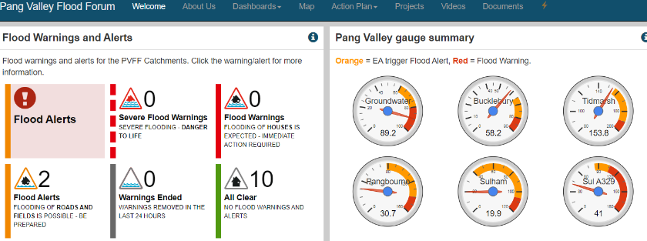
Pang Valley Flood Forum Website : https://www.floodalleviation.uk/

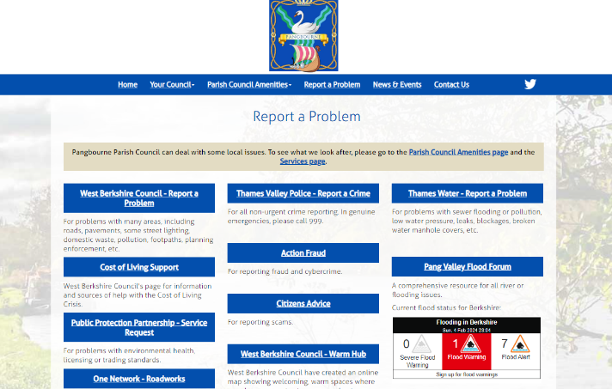

It can also be accessed by clicking through from the “report a problem” page of links on Pangbourne Parish Council’s website.

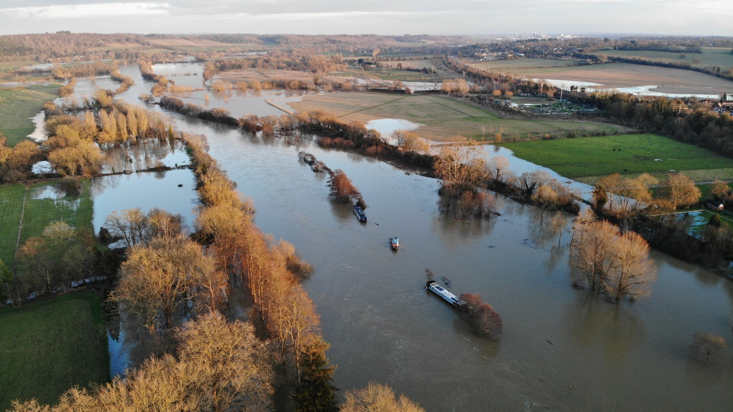

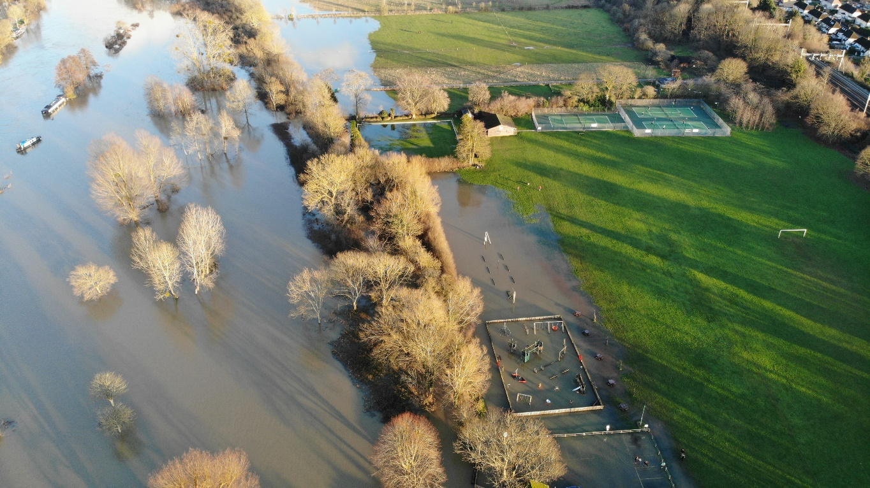

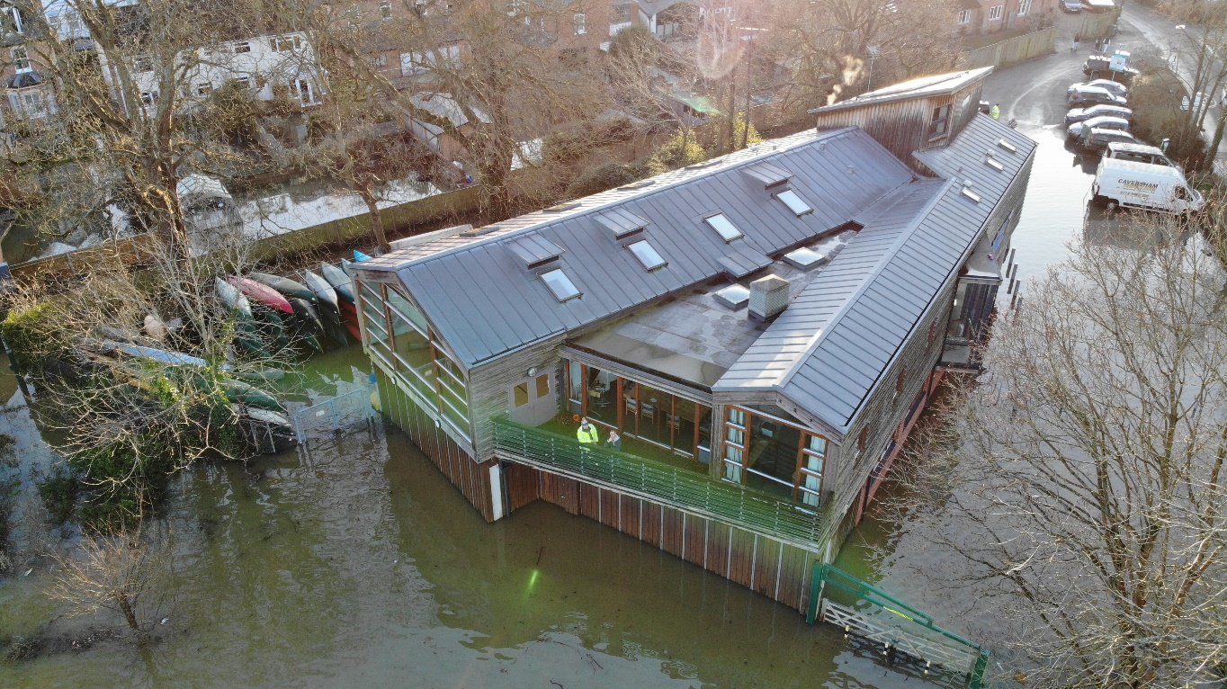

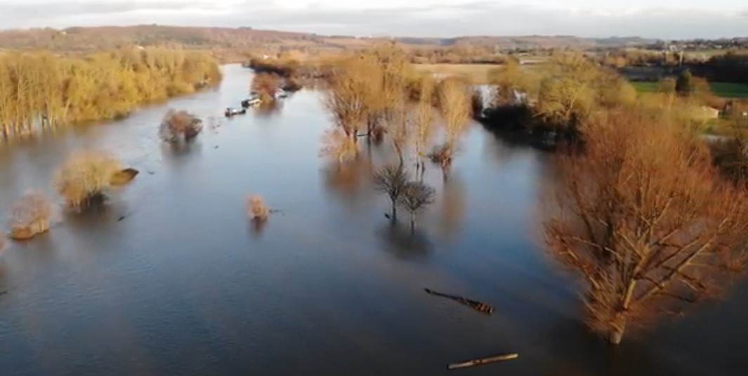
All Photos Credit: Darran Taylor

Parish Council Budgets 2024-2025
BUDGET (vat inc) | £290,340
PRECEPT | £209,746
BAND D PER YEAR (approx.) | £131.40
BAND D PER WEEK (approx.) | £2.52

The Parish Precept is the amount collected by West Berkshire Council on behalf of Pangbourne Parish Council from local residents in order to deliver services within the Parish of Pangbourne.
This year’s Precept for 2024/25 has now been set at £209,746 although the total Expenditure Budget for the council for the year is higher £290,340. The remainder of the funds required to meet this budget are made up of other income from the Village hall and amenities plus other sources of funding and the monies apportioned to the Council as Developers Contributions (CIL funding), Grants, Allotment and Cemetery fees and so on.

Bus Services - Update
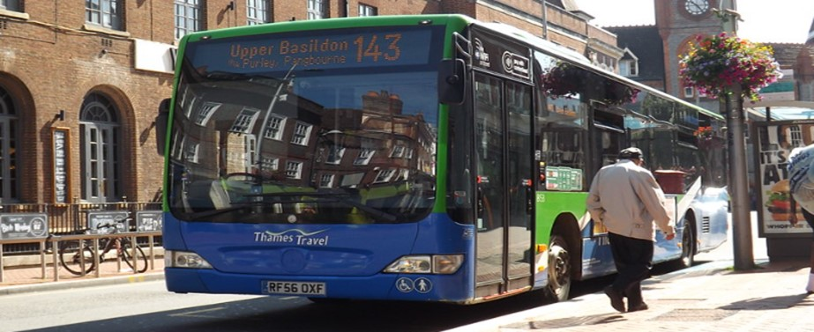
Following on from our article in the Autumn edition of the magazine highlighting West Berkshire Council’s consultation on local bus services in Pangbourne we would like to thank all residents who responded to the survey.
The consultation asked for views in the BSIP (bus service improvement plan) on the proposed creation of “on demand” services for local villages which would be achieved by building a bus turning circle (most likely) in Station Road Car Park and potential changes to local services which would have affected the BB3 service to Langtree School as well as differences in timetabling and routes for the 143.
The Parish Council expressed strong concern to WBC regarding several elements of the proposal and their impact on local services. The plan could have resulted in the loss of a significant number of parking spaces in the main carpark and re-routed pedestrian access to the village hall as well as the potential loss of the well used BB3 bus. The 143 would also no longer have run onwards to surrounding villages. The Parish Council did, however support increasing the frequency of buses to Reading.

We have now received an update on the proposals from West Berkshire Council to the effect that the project has not received local authority support and therefore will not be progressing any further.

Millennium Award 2023-24 - Voting Live!
Voting for the Millennium Award is live again.
It will be presented at the Annual Parish Meeting on TUESDAY 23rd APRIL 2024.

This is a really exciting opportunity to vote for residents or groups who have made a significant contribution to the Village. We know there will be many worthy candidates who have helped to make a difference to the life and people of our local community. It would be lovely to see nominations representing all age groups and interest groups and organisations in the village.
Please see the separate form and information on how to nominate elsewhere in this issue.
Nominations close on FRIDAY 29th MARCH 2024 and should be returned to the Clerk at the parish office.

Annual Parish Meeting - Tues 23rd April 2024
HAVE YOUR SAY AND BE INVOLVED!
The Annual Parish Meeting will return on Tuesday 23rd April 2024. This is a meeting of the residents of the Parish and is your opportunity to come along and hear updates from and find out information about local groups and societies. It will also be your chance to meet Parish Councillors and the elected District Councillor and hear what the Parish Council have been working on over the past 12 months as well as plans for the coming year. It is also a chance to have your say or share ideas! The Millennium Award for 2024 will also be presented (see separate nomination form).
We would love to see as many people there are possible, so please make a note in your diary!
If you would like to present on behalf of a group or project please contact the Clerk so that we can schedule you in.

Everyone is welcome – this is not a parish council meeting but a meeting of the parish and its residents.

Tuesday 23rd April 2024
7.30pm at Pangbourne Village Hall
Refreshments from 7pm

Parish Council Grant Awards 2024/25 Year

The Parish Council have limited funds available each year for grants to groups, charities and organisations within the Parish that meet certain criteria.
The Parish Council would like to invite applications for 2024/25 financial year from local groups that meet these criteria to fund projects for the benefit of the residents of Pangbourne.
Applications should be received by 1st April 2024 for consideration at the May council meeting, although it is possible that applications received after this date may be considered in a second round of grants in September if there are funds remaining.
Please see the website or contact the Clerk on Clerk@Pangbourne-pc.gov.uk for further information or an application form.
In 2023/24 year the Parish Council was able to help fund a number of projects including a grant to Pangbourne Tennis Club towards their new floodlights, support for the continued operation of the public toilets at Station Road carpark, and Pangbourne library and the 143 Bus Service as well as a number of smaller charities.
The council continues to provide funds to support both the local bus service and the library.

Youth Football Storage Container

New storage at the Recreation Ground for Pangbourne Youth Football
Pangbourne Parish Council and Pangbourne Youth Football have been awarded a grant of £4,965 by the Football Foundation towards the cost of purchasing a shipping container for storage.

Pangbourne Youth Football Club provides a fun, safe, inclusive and competitive environment for young players in Pangbourne to learn, grow and participate in football. Their activities are attended by over 270 girls and boys from ages 4 to 17, with support from more than 30 parent volunteers.

The new container will provide the Youth Football teams with much needed storage space for their training equipment. It will be positioned at the far end of the recreation ground next to the tennis courts and football pitches. Match funding for the project has been provided by the parish council, Pangbourne College Community Fund and Pangbourne Youth Football.

PANGBOURNE VILLAGE HALL –
NEW BOOKING EMAIL ADDRESS
The new email address for all hall booking enquiries is:

bookings@pangbourne-pc.gov.uk

CHILDRENS PARTIES
HIRE RATE - £65.00

* SATURDAYS & SUNDAYS

* 4 HOUR HIRE

* USE OF KITCHEN AND MAIN HALL

* CAR PARKING AT REAR

* SMALL HALL ALSO AVAILABLE FOR PARTY HIRE

Pangbourne Village Hall, Station Road,
Pangbourne, RG8 7AN

Hall Booking Clerk: 07747 884341
Email: bookings@pangbourne-pc.gov.uk

Website: https://www.pangbourne-pc.gov.uk/Hall_Bookings

