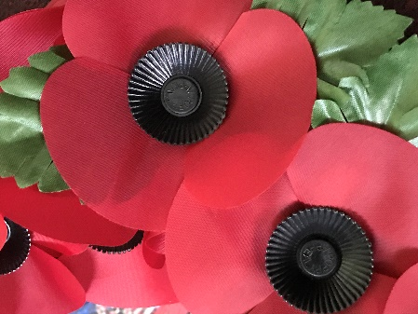
REMEMBRANCE SUNDAY EVENT NOVEMBER 14TH 2021 3PM

*UPDATE*

THE FINAL ARRANGEMENTS HAVE NOW BEEN MADE FOR THIS YEAR’S SERVICE OF REMEMBRANCE.
A SHORT OUTDOOR SERVICE LASTING APPROX 30 MINUTES WILL COMMENCE AT 3PM IN THE GROUNDS OF THE CHURCHYARD OF ST JAMES THE LESS .
UNFORTUNATELY, THERE WILL BE NO PARADE THIS YEAR AFTER ALL.
PLEASE CAN THOSE ATTENDING THE OUTDOOR SERVICE GATHER IN THE CHURCHYARD OR ON PANGBOURNE HILL ONLY AS THERE WILL NO ROAD CLOSURES IN PLACE FOR STATION ROAD /CHURCH ROAD OR ANY OTHER ROADS THIS YEAR.
WE KINDLY REQUEST THAT THOSE ATTENDING OR PARTICIPATING OBSERVE GOOD SOCIAL DISTANCING WHERE POSSIBLE AND CONTINUE TO BE COVID AWARE FOR THE BENEFIT OF ALL WITHIN THE COMMUNITY.

