Project ref: SOE4997
Dear Gas Customer

We’re upgrading our gas network in Streatley

I am writing to notify you of our project to replace the gas pipes in Streatley. We are replacing our old metal gas mains and services with new plastic pipe. This essential work will ensure your community continues to receive a safe and reliable gas supply.

Our contractor I & G Contractors Limited, who will be completing this project on our behalf will start work on 15 May for approximately 20 weeks.

The project will be completed in the phases itemised below. To ensure the safety of everyone around our work site we may need to close a road, in this instance, access will be maintained for residents and businesses and a signed diversion will be in place.

Please note that the dates may move dependent on the progress of the work, likewise, if we experience any engineering difficulties, the traffic management may change, however we will update you.
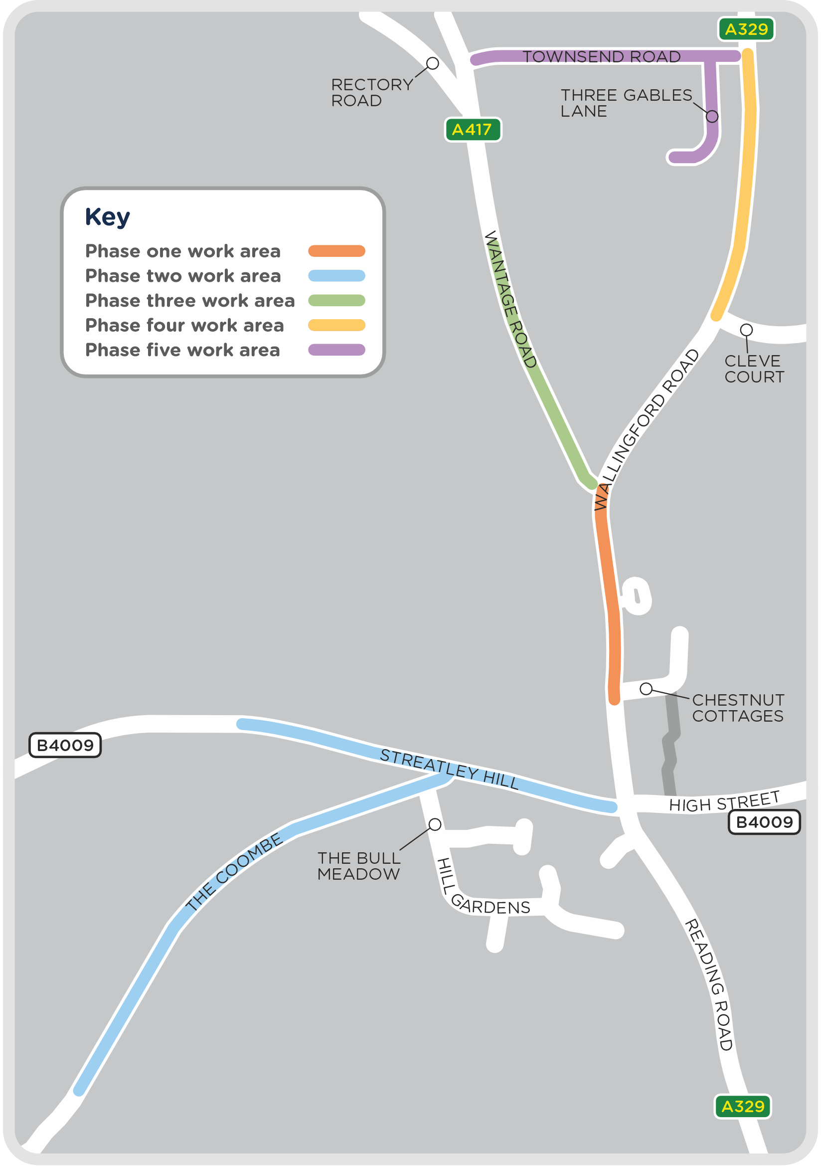
Phase one – Work starting on 15 May
Wallingford Road – we will be working in Wallingford Road from 15 May for approximately six weeks. The road will be closed between the junction of Wantage Road and Chestnut Cottages.

Chestnut Cottages – Will have access via the High Street.

Phase Two – Work Starting on 24 July
Streatley Hill – our team will move into Streatley Hill from 24 July for approximately three weeks. The road will be closed during this time at the junction of The Coombe. Access to The Coombe, Lewendon Hill, Bull Meadow and Hill Gardens, will be signposted as works progress.
The Coombe – Temporary traffic lights will be in place in The Coombe from 24 July for approximately seven weeks.

Phase Three – Work starting 4 September
Wantage Road – Our engineers will be working in Wantage Road from
4 September for approximately six weeks.

Phase Four – Work starting mid September
Wallingford Road – Our engineers will be working in Wallingford Road for approximately six weeks. Temporary traffic lights will be in place at the junction with Townsend Road to allow traffic to safely pass our work site.

Phase five – Work starting October
Townsend Road – We will be working in Townsend Road for approximately six weeks, we will be asking traffic to ‘give and take’ past our worksite.
Three Gables Lane – We will be working in Three Gables Lane for approximately four weeks, we will be asking road users to ‘give and take’ past our work site.

We understand that people can get frustrated by roadworks, and therefore we only use traffic management that we feel is efficient enough to complete these works safely for ourselves and the public.

Please contact us at customer@sgn.co.uk if you have any queries.

If you’ve got any questions, please don’t hesitate to get in touch with our Customer Service team. Once our engineers start work, they’ll also be happy to answer questions at any time during our project. Please remember to keep a safe distance when speaking to our team or passing our site.
Thank you in advance for your co-operation.

Yours faithfully

Matthew Morland
Project Manager

