FREQUENTLY ASKED QUESTIONS

PANGBOURNE VILLAGE HALL

PLEASE ENSURE THAT YOU READ THE FULL HIRE TERMS & CONDITIONS PRIOR TO MAKING YOUR BOOKING (www.pangbourne-pc.gov.uk/Hall_Bookings_34785.aspx)

Where do I collect the key for the hall?
For one-off bookings, please collect the key from Launderclean (opposite the Village Hall on Station Road).

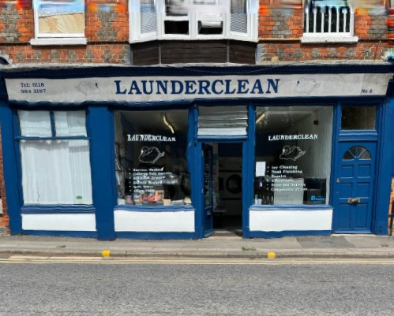

Opening hours are Mon-Sat 8.30 to 1pm.

The key should also be returned to Launderclean. If returning the key outside of their opening hours, please slide the key through the blue louvre doors at the rear of the shop.

For bookings on Saturday (after 1pm) & Sunday
Please collect the key from Launderclean before 1pm on Saturday or in emergencies you can collect and return a key to the Reception at Elephant Hotel, next door to Village Hall on Church Road, RG8 7AR

What size/capacity is the hall? – see website for photographs
Main Hall – 100 standing, 80 seated
Small Hall – 50 standing, 30 seated
Chairs and tables available for use by hirers.

Can I have a bouncy castle in the hall?
No.

Can I use a smoke machine at my event?
No. These set off the fire alarm.

Can I put up decorations?
We understand that you may want to decorate the hall, particularly for children’s parties but we would ask you not to attach anything to the walls or paintwork with Blu Tack or sticky tape as it causes damage to the paint work.

Are there any other facilities at the hall?
There is a large projector screen and PA system (microphones and stands) – please ask Booking Clerk for details.

Is there parking at the hall?
The car park to the rear and side of the hall is available to hall users (approx.18 spaces). Cars are parked at owner’s risk. There is also a large public car park in front of the hall which is free after 6pm and on Sundays.

What kitchen facilities are there at the hall
Main Hall: 6-ring gas hob and oven, hot cupboard, fridge/freezer, urn, dishwasher, large tea-pots, cups and saucers, side plates, mugs, trays. Please note there are no glasses, cutlery, tea towels and tea/coffee/sugar.

Small Hall: Sink, 2 kettles, large teapot, cups and saucers, mugs.

Can I show films/play music?
The premises is licensed by PPL PRS for the playing and performance of copyright music. You must ensure that you have the appropriate copyright licences for films.

Can I sell alcohol at my event?
If you want to sell alcohol at your event (or include a free drink in your ticket sale) you will need to apply to West Berkshire Council for a Temporary Events Notice (TEN). You can apply online at: www.westberks.gov.uk/article/37094/Apply-for-a-Temporary-Event-Notice. You must apply 10 clear working days before your event. You will need a TEN for each event at which alcohol is sold. You can get up to 5 TENs a year and the current cost of a licence is £21. You will need to supply the Booking Clerk with a copy of the TEN prior to your event.

Is there Wifi in the hall?
Yes, the code for the Wifi is displayed in the foyer. We cannot guarantee that the service will be fault free.

What happens if I damage something in the hall?
All damage and breakages are to be reported and a charge will be made for replacement. It would be appreciated if faults, e.g. non-working light bulbs, could also be reported or recorded in the Defects Book attached to the notice board in the foyer. If there are any urgent issues, please contact the HALL BOOKING CLERK on 07747 884341.

Any accidents should be recorded in the accidents sheet located in the foyer.

What happens if I don’t leave the Hall as I found it?
If we need to pay for the hall to be cleaned or any repairs to be carried out after your booking, we will retain all or part of your deposit to cover the costs of this cleaning or repairs. Please refer to the Terms and Conditions and Hall Hire Checklist for cleaning requirements.

When/How will my deposit be refunded?
Damage deposit refunds will usually be processed on the 2nd Wednesday of the month following your event. You will need to tell us the bank details (name, sort code, account number) to which you wish the deposit to be returned. Please EMAIL YOUR BANK DETAILS to belkin@pangbourne-pc.gov.uk stating the name/date of your booking.

