

MINUTES OF PANGBOURNE PARISH COUNCIL

Minutes of the full meeting of the Council held at Pangbourne Village Hall on Tuesday 9 Sept 2025 at 7.30pm.

PRESENT:
Cllrs: I. Walker (Chairman), J. Higgs (Vice Chairman), T. Batten, C. Brewer,
G. Child, C. Ellis, N. Goodwin, B. Kerr-Muir, M. Rimmer, C. Roberts,
Clerk: R. Elkin (Clerk, RFO),
District Cllr: Cllr M. Shakespeare
Members of public: Over 100 members of the public were present for part of the meeting
Members of West Berkshire Council: J. Brooks, J. Holmes, J. Pemberton
APOLOGIES RECEIVED: None
ABSENT: None

Section 1: Procedural

2149 | To receive apologies for absence and declarations of interest relevant to agenda items
No apologies were received
No Councillors were marked absent
No Declarations of Interest were given

2150 | To RESOLVE to adopt the minutes of the full council meeting held on 8 July 2025 as a true and accurate record
 | Having been previously been circulated and taken as read, the minutes of the meeting of 8 July 2025 were approved and signed as an accurate record with no amendments.

Section 2: Decision Making
 |  | Action
2151 | Local Government Reorganisation  - To RECEIVE a presentation from the leader of West Berkshire Council (Jeff Brooks), Lead Member on LGR (Justin Pemberton), Chief Executive of WBC, Joseph Holmes and District Councillor (Matt Shakespeare) on the proposed Local Government Reorganisation including plans for a new Ridgeway Council and to discuss the alternative proposal put forward by Reading Borough Council for a “Greater Reading”  - To RECEIVE an update from Pangbourne Parish Council on this matter  - To take public Q&As
Before the representatives of West Berkshire Council began their presentation, the Chairman gave a brief overview of the services the Parish Council delivers for the local community and stated that he believed it was the majority view of residents that they would wish to stay as they are or in other words continue to be served by a parish council. He reiterated that the money raised by the Precept is raised by and solely for residents of the parish. There were concerns over what would happen should the parish become part of a Greater Reading.

Cllr NG stated that he wasn’t aware that the reorganisations would produce any increase in funds and so was it realistic to believe that there would really be any greater benefits created by the changes. He also questioned what the benefits were to the parish of staying within a Ridgeway Council as the parish would continue to be on the very eastern fringes of a much larger council. He noted that the eastern parishes already feel forgotten in expenditure and focus terms. WBC Leader JB responded that the parishes of the east were very much seen as part of WBC/Ridgeway and to “ask and you shall receive”.

The Chairman then thanked everyone for coming along to tonight’s meeting and stated that the public turnout was one of the highest he had seen and that the packed room served to demonstrate the importance of the issue to many residents. He also thanked the three representatives of West Berkshire Council for sparing the time to come along to present to residents and for their plans to visit all 6 of the potentially affected parishes.

It was ascertained that no-one wished to speak on any other matter than the LGR and so it was agreed that the meeting would not include a public forum tonight as residents were able to ask questions on that as part of the main agenda item.

WBC Leader, Jeff Brooks started by explaining the government’s plans for the local government re-organisation which in effect meant that across the country (as a generalisation) roughly every three local authorities of WBC’s size (c184,000 residents) would ideally need to group together to form new authorities like the proposed Ridgeway with c500,000 residents. Above this would be a further tier of local government, consisting of roughly three of these new authorities to form an area with 1.5million residents which would be represented by an elected mayor to deliver strategic infrastructure. He explained that there are currently 1.7million residents across Berkshire and Oxfordshire.

Across the country, there are approx. 317 local authorities considering proposals for their future structure.

He described the contradicting proposal by Reading Borough Council, which would see Pangbourne amongst 6 parishes being moved into a Greater Reading, as an “unwelcome and hostile land grab”.
JB then gave the following presentation in summary:

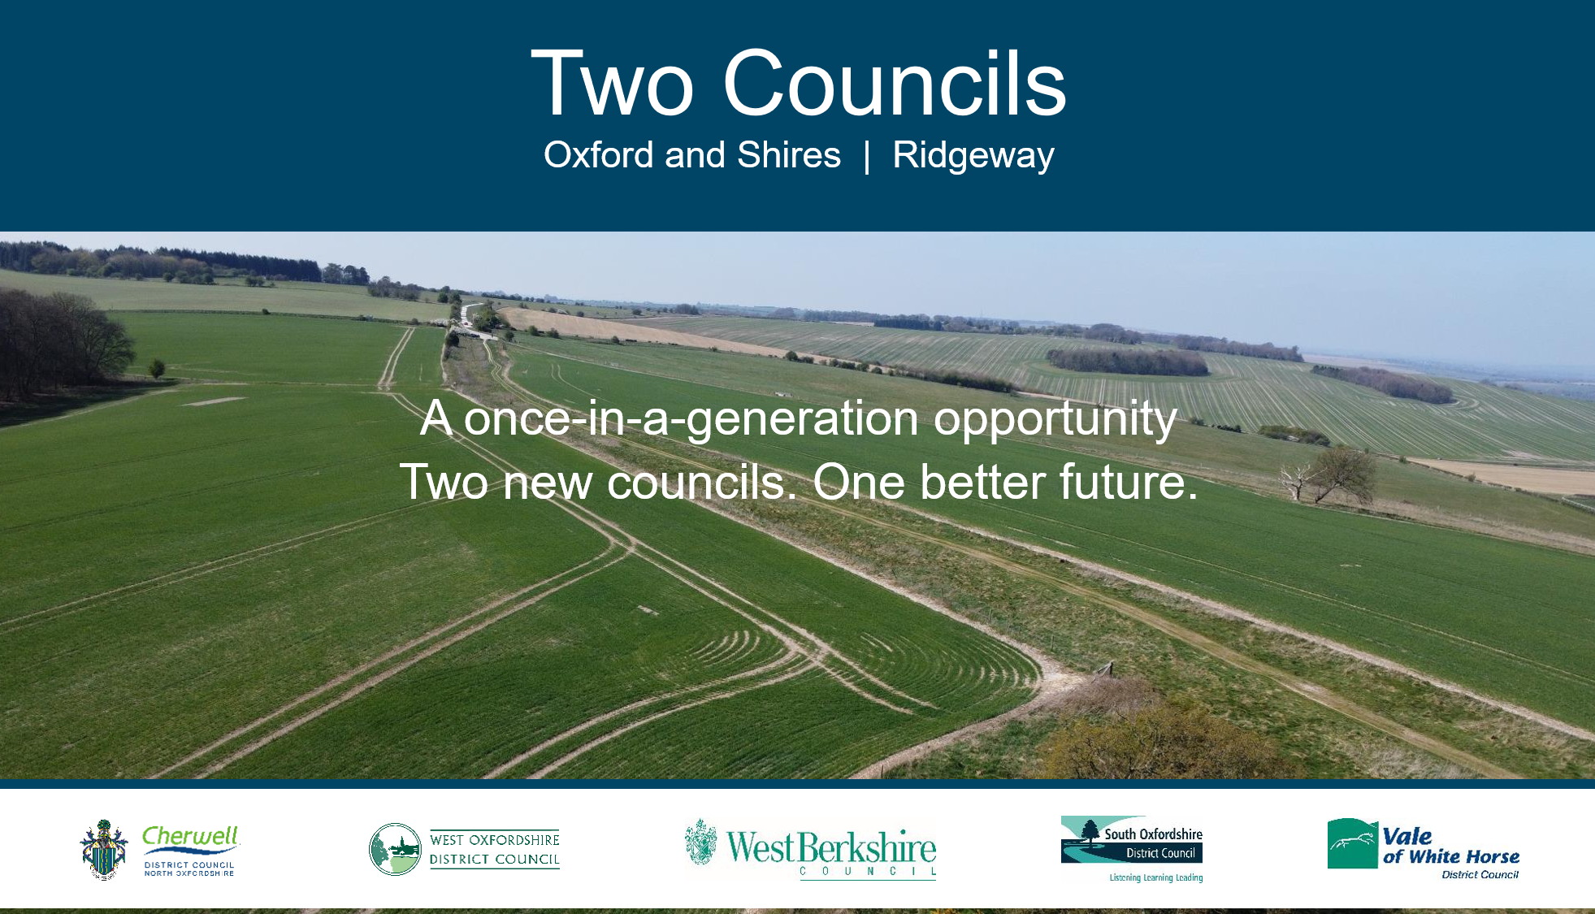
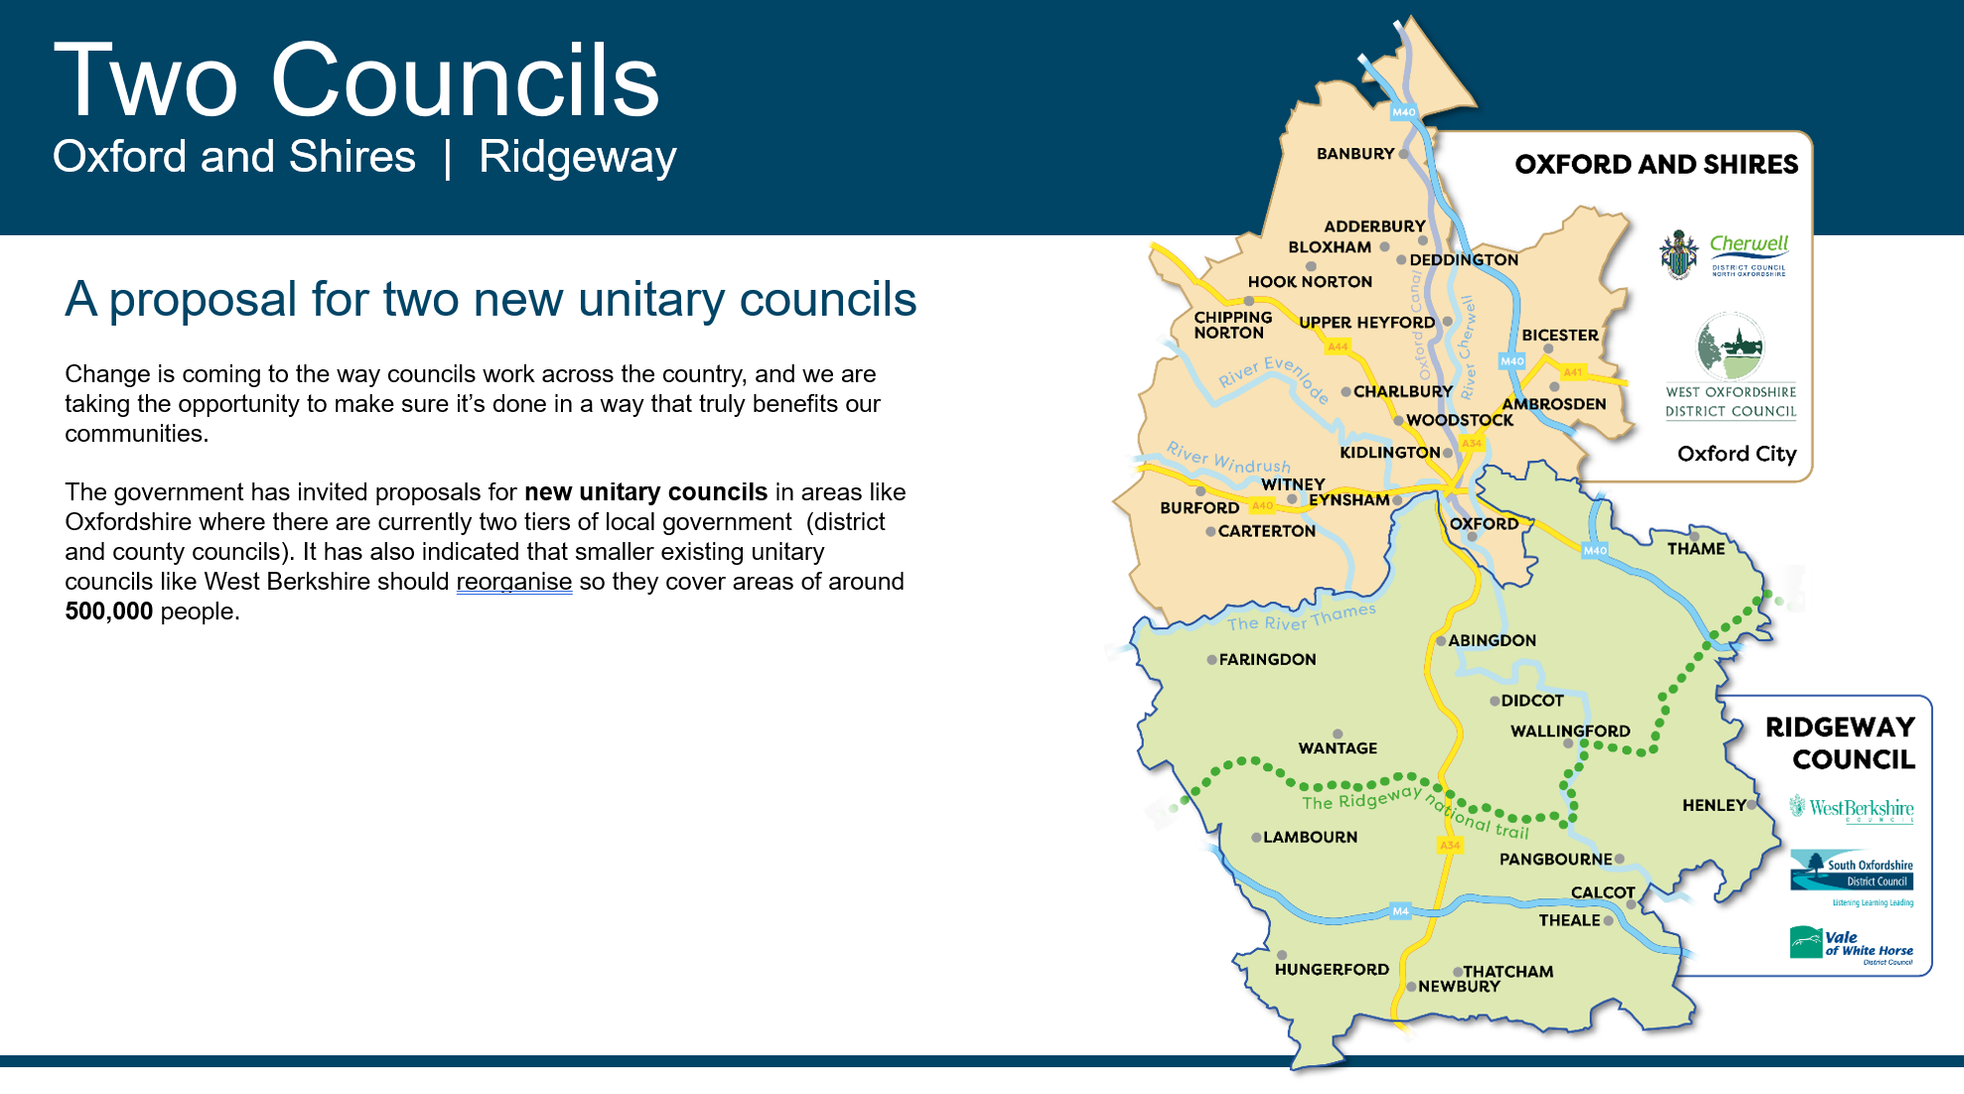
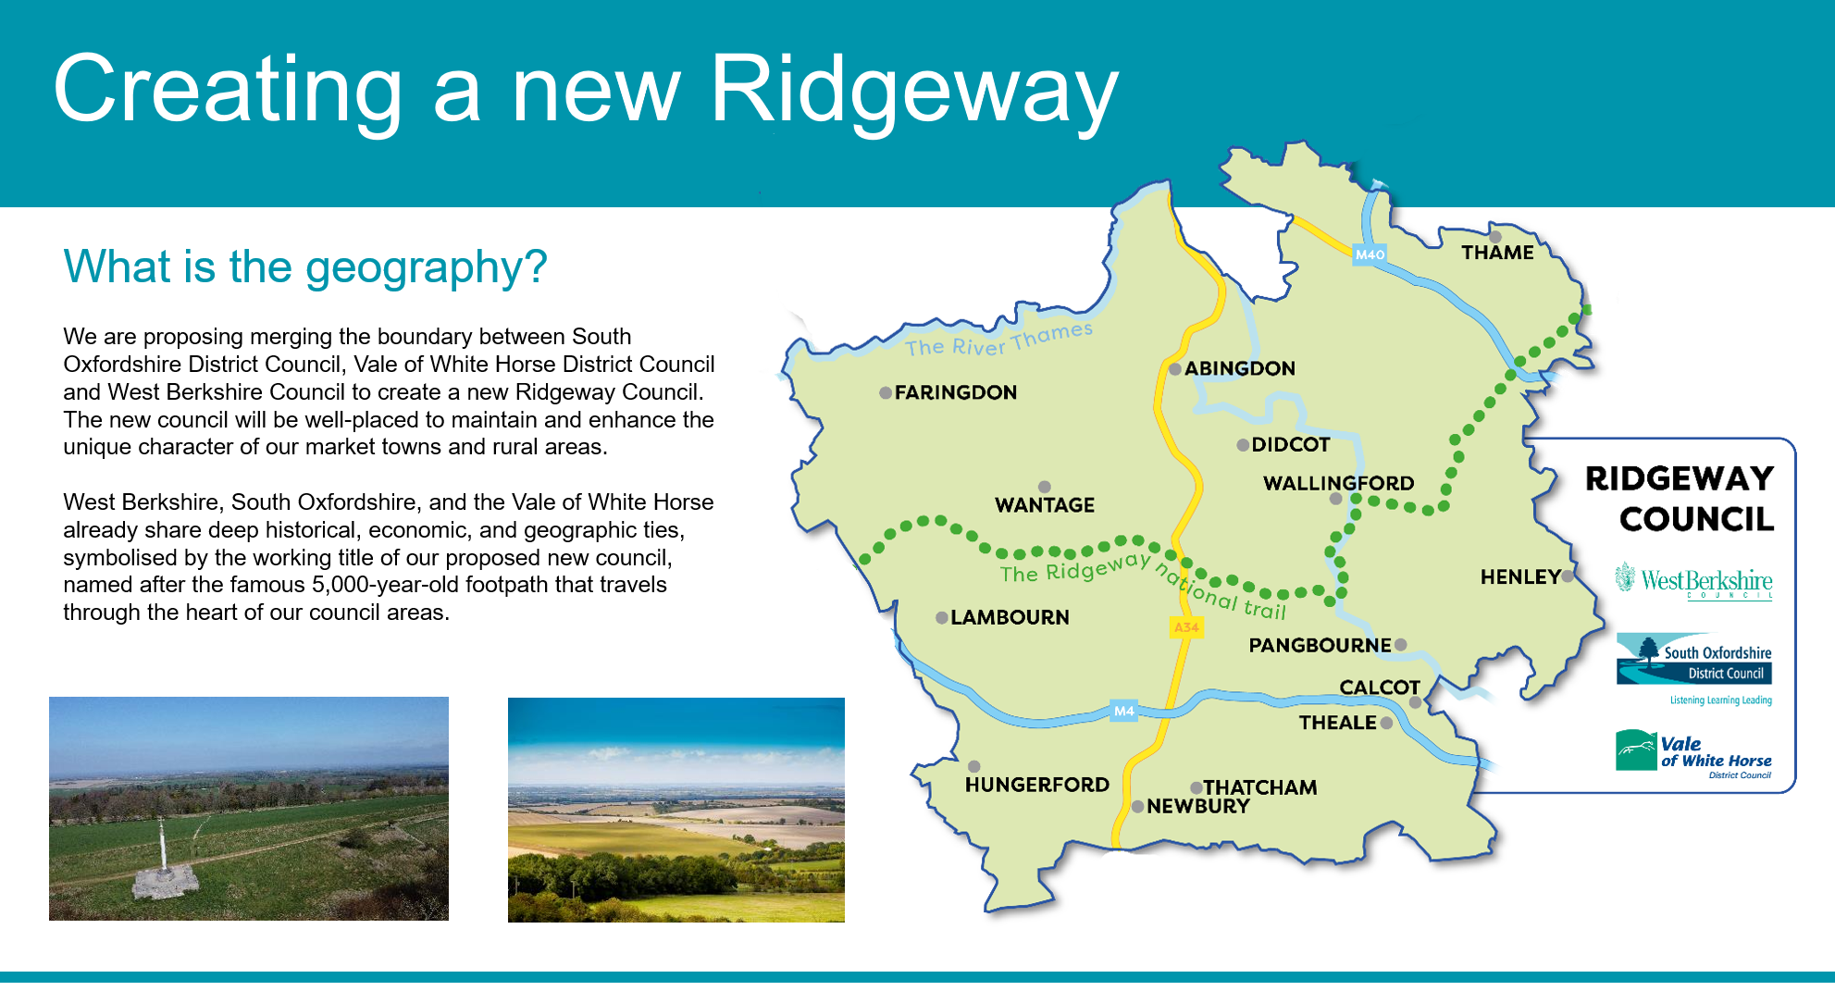
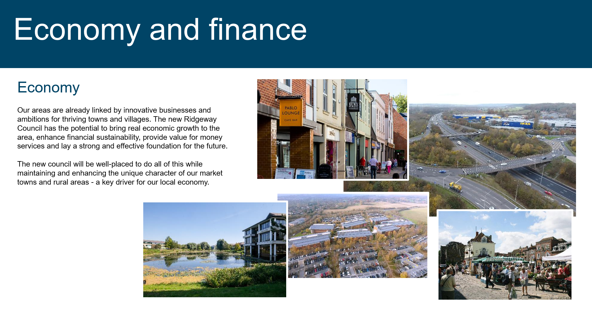
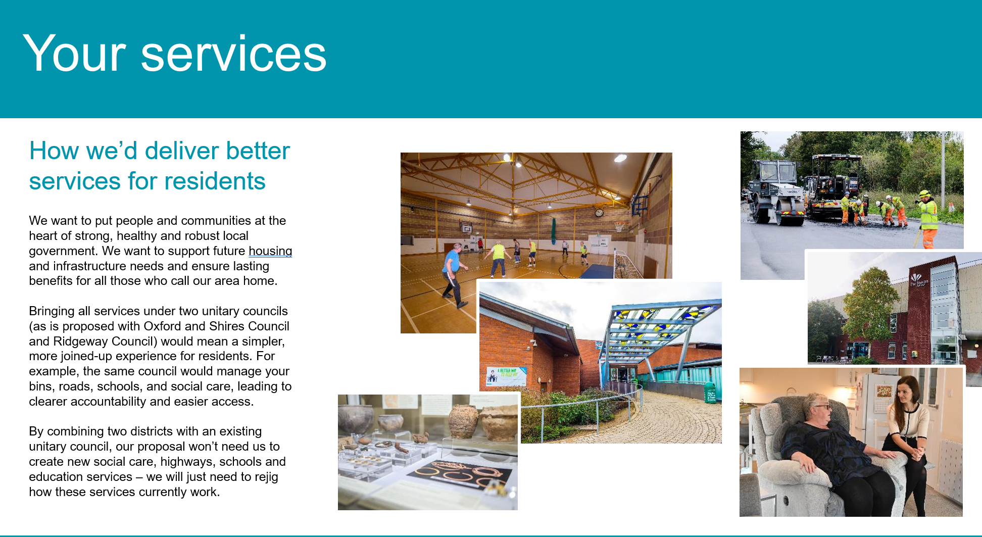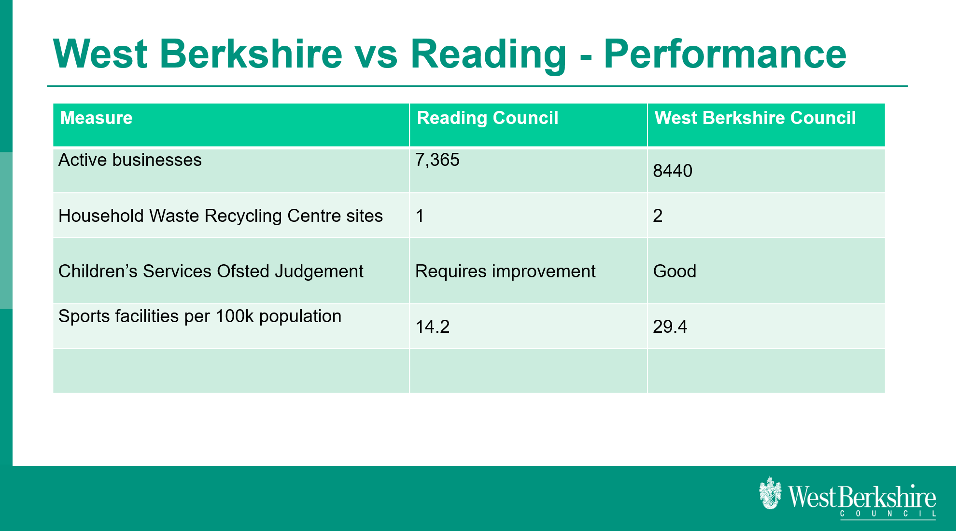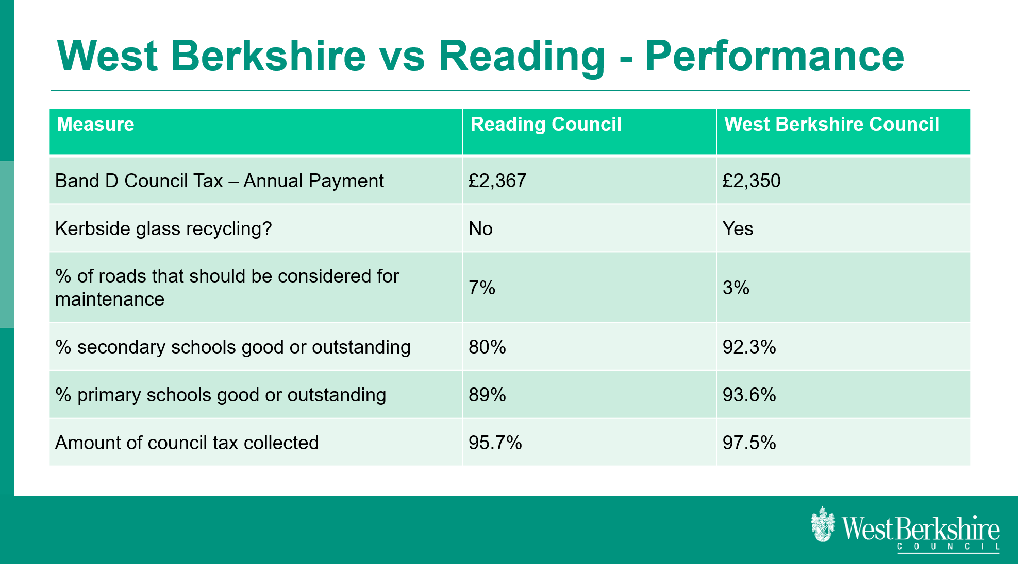

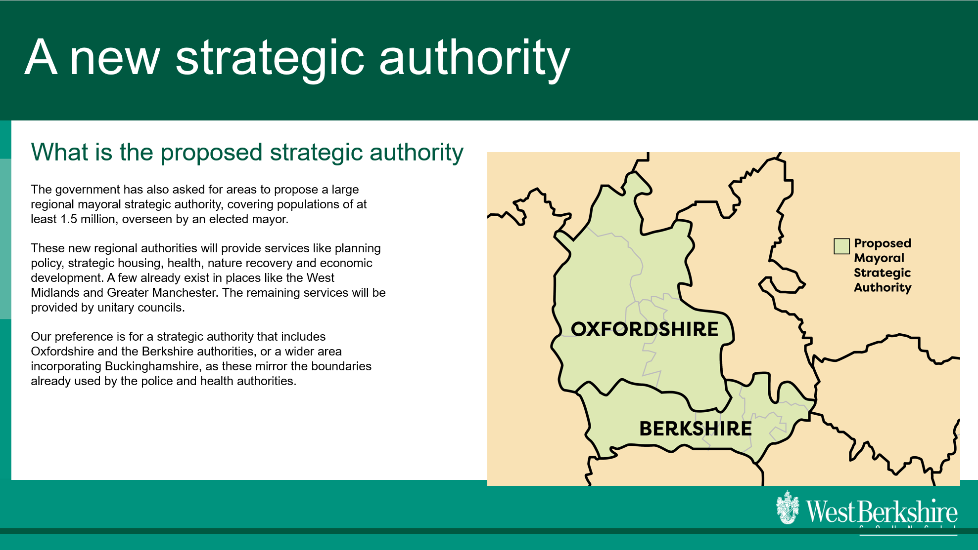

District Councillor Matt Shakespeare also spoke briefly to the meeting about some of the recent issues that he has worked on for the village:
- working in partnership with Pangbourne Parish Council to keep the library open for longer on Saturdays (funded by PPC)
- work to re-route local school buses to reduce the long journey times and work to ensure there are sufficient spaces for all children who need them
- work to look at improvements for Bourne Rd playground (WBC operated)
- funding the new recreation ground path

JB explained that the re-organisations won’t solve issues such as those with adult social care or its funding but that this was something that local authorities were being asked to do and which was being driven centrally.

The floor was then opened up to Q&As from residents who asked a broad range of questions several of which are summarised here:

Q: What is the timeframe and what happens next?
Q: When will any financial figures on potential savings be published and will these be produced publicly?

A: Both Reading Borough Council and West Berkshire Council are currently consulting with residents and will put their final proposals to central government at the end of November. In late November both authorities will need to put forward their detailed business cases. For WBC this is being drawn up and audited by KPMG independently. The Government will then need to decide whether to allow RBC’s proposal to alter the local authority boundaries (as it is unclear whether this was permitted within the scope of the white paper).

Q: I was a ward member for Pangbourne in the 1990s when the county of Berkshire was split into the current 6 unitary authorities and I resigned because it was a bad idea at that time and I’m not convinced that the current proposals are the answer either.

A: Jeff Brooks explained that he was the last Chairman of the old unified Berkshire Council and was therefore also around at the time of that re-organisation. He stated that he felt the Ridgeway Council proposal being put forward was best placed to serve residents in the future.

Q: South Oxfordshire District Council currently provides free school transport and school buses. West Berkshire Council does not and this is a significant cost for parents in an essentially rural district where children cannot walk to school. What will happen with the proposed Ridgeway merger?

A: JB and JH stated that they were not aware of this and would need to look at many details such as these as any proposals progressed. They agreed to consider this matter.

Q: I Have written to Olivia Bailey MP who appears to be firmly advocating for Pangbourne to join Reading. How can she represent us impartially?

A: Residents were encouraged to write to their MP to express their views and her contact details were shared with the meeting. It was noted that she is currently asking residents to do so.

Q: Where will the new Ridgeway HQ be based?

A: This has not been decided yet and the detailed work will not be undertaken until it is clear that the proposal is likely to go ahead. JB stated that resources are tight for all local authorities and it would be wrong to spend too much time and expenditure on detail at this stage that may not be progressed. There was a commitment to look at providing local hubs in WBC facilities such as the library should the Ridgeway be taken forward so that residents could access services locally.

Q: How are we sure that the Green Belt and National Landscapes that make the area so special will be protected?

A: JB stated that WBC has a long history of protecting both and that should Ridgeway go forward this will continue to be the case as is stated in the authority’s Local Plan.

Q: There is a very real risk that the village will be left without postal or banking services when the current arrangement in Collins ends next year. What will WBC/Ridgeway do to support the community if this happens?

A: WBC has models in place for banking hubs and circulatory banks which could be based in the library and these could be explored.

Q: How will the new mayors be funded? Surely the creation of this new bureaucratic layer will negate all of the claimed savings by merging councils?

A: This was a question for central government to answer based on their proposed new structures and the work they had done to cost them.

Q: What would happen to arrangements on issues of local importance such as the charity funded toilets?

A: It was stated that WBC/Ridgeway would continue to encourage and support these and JB was corrected in that these toilets are entirely charity run at present.

It was noted that WBC had been approached by South Oxfordshire District Council and the Vale of the White Horse Councils who both needed to re-organise.

Following the presentation and Q&A session, the WBC representatives and nearly all of the members of the public left the meeting and the normal session continued.

2152 | To agree a course of action for Pangbourne Parish Council on this matter
It was stated by District Cllr MS that he had started a petition against the boundary changes proposed by RBC as had the District Councillors for Theale and Purley. He had previously given out details and urged residents to engage.

It was also suggested that a more formal Parish Poll be investigated.

It was agreed to write formal letters to WBC, RBC, MHCLG and the MP, and for the Clerk to investigate the process of holding a poll.

A long factual article notifying residents of the proposals has already been shared in the village magazine, parish website and social media.

2153 | To note the submission of a Members Bid for a replacement village sign and the offer of sponsorship from a local business
It was reported by the Clerk that the application for a Members Bid grant towards the repair/replacement of the village sign has now been submitted and has been supported by the District Councillor.

Significant private funding has also been offered by a local business.

It is anticipated that the total cost will be in the region of £9k due to the specialist nature of the carving work involved.

2154 | Planning:  - To receive the list of planning applications since the last meeting | Comment
 | None
 | - To discuss and agree responses not already RESOLVED by Planning Committee plus any other urgent applications received before the meeting:
 | 25/01527/HOUSE Rodney, Bere Court Road, Pangbourne, RG8 8JY | No Objection
 | 25/01690/HOUSE 19 St James Close, Pangbourne, RG8 7AP | Objection
 | 25/01720/HOUSE Low Wood, Green Lane, Pangbourne, RG8 7BG | No Objection
 | 25/01856/FUL Lower Bowden Manor, Bowden Green, Pangbourne, RG8 8JL | No Objection
 | 25/00458/HOUSE Broome House, Green Lane, Pangbourne, RG8 7BG  (Reconsulting following additional plans) | Objection
2155 | Finance:  - To RESOLVE to APPROVE accounts reconciliation at 31 August 2025  - To RESOLVE to APPROVE the payment schedule as appended to the agenda for August and Sept 2025  - To NOTE any progress on the External Audit for 2024/25
- The accounts reconciliation for 31 August 2025 as appended to these minutes was circulated outside of the meeting and approved.
- The payments due in August and September 2025 totalling £34,917.22 and £21,762.24 as appended to these minutes were approved.
- It was noted that the External Auditor has now issued the Notice of Conclusion of Audit for the year 2024/25 with no significant issues raised. It was noted that Risk Assessment reviews had been undertaken with a 14 month gap between instead of within 12 months. The Notice will now be displayed as required. The Clerk also highlighted the new digital and data assertion 10 which will be introduced to next year’s audit and that this will require proper attention in advance by the Council as it is a very wide ranging assertion which needs to be addressed thoroughly to ensure full compliance.

2156 | Policies and Procedures  To consider to RESOLVE to approve the policies previously circulated and taken as read.
 | None

Section 3: Updates and Progress Reports
 |  | Action
2157 | Reports from committees, working parties and individual councillors
VILLAGE HALL
- The clock has been fully repaired over the summer recess
- There are issues with all the boilers at the hall which are being addressed

GROUNDS
- MTG next phase of funding
- The fencing repairs around the carpark (and to some extent playground) are now becoming urgent
- We need to publish the results of the public consultation in the magazine

2158 | To receive a brief report from the Chairman  - IW reported on developments with speedwatch and has requested equipment.  - MS reported that the mobile VMS sign proposed to be purchased for Tidmarsh PC is in the region of £2,800.
2159 | Clerk’s Report  - The Clerk confirmed with Cllrs that they are happy to write a letter of support for Thames 21’s application for clean water designation from DEFRA now that the wording has been changed from “bathing water” to “recreational water”.  - The Clerk stated that she has begun making arrangements for both Remembrance Day and Village Xmas Evening.  - It was noted that the PSPO (Public Spaces Protection Order) has come into force over the summer recess and appears to have made an initial difference in “calming things down“ at the meadows and making it a safer and nicer place for residents to enjoy over the summer months. The OS Warden reported that she had seen more families using the space and there was reduced littering. The full impact of the PSPO will remain to be seen next year as it was not in place in time for exam season this year.  - It was further reported that the Adventure Dolphin youth activities, which PPC had supported via a grant, had seen over 1,000 children use the centre.
2160 | To receive a report from the District Councillor  - The District Councillor made further comments in relation to the work he has been undertaking on the boundary proposals and LGR.
2161 | To answer questions from councillors, request items for next meeting or receive items for information only
 | - One Cllr stated that she had received complaints regarding drug dealing in one particular area of the village centre and was asked to report this to the TVP Neighbourhood team
2162 | Correspondence:  None not already previously circulated or discussed.

Section 4: Confidential Session
 | Pursuant to section 1(2) of the Public Bodies (Admission to Meetings) Act 1960 it is RESOLVED that, because of the confidential nature of the business to be transacted, the public and the press leave the meeting during consideration of the items detailed below.
2163 | - The annual NJC pay award was noted as having been agreed. It was noted that this was earlier than in previous years, however it will be backdated to April and applied to the next payroll.

Section 5: Closure

2164 | There being no further business the Chairman closed the meeting at 9.40pm.  The next scheduled meeting will be held on Tuesday 14 Oct 2025 at 7.30pm.

_________________________ Chairman ___________________ Date

PLANNING APPLICATIONS TO BE REVIEWED AT OR BEFORE PARISH COUNCIL MEETING ON
9 September 2025

APPLICATION NUMBER | PROPOSAL | Recommendation
25/01527/HOUSE | Single storey front porch. Single storey side extension to create utility room. Single storey rear extension for new kitchen/dining/family room. Two storey side extension to create new master bedroom with en-suite. Internal alterations.  Rodney, Bere Court Road, Pangbourne, Reading RG8 8JY | No objection
25/01690/HOUSE | Retrospective: Single storey side extension  19 St James Close, Pangbourne, Reading, RG8 7AP | Objection
25/01720/HOUSE | Demolition of existing conservatory, proposed ground floor rear extension, fenestration alterations, pergolas, floor plan redesign and all associated works.  Low Wood, Green Lane, Pangbourne, Reading RG8 7BG | No objection
25/01856/FUL | Change of use, conversion and extension of two redundant rural barns within the curtilage of Lower Bowden Manor, into a residential dwelling, to be known as the Dower House.  Lower Bowden Manor, Bowden Green, Pangbourne, Reading RG8 8JL | No objection
25/00458/HOUSE  (Reconsulting following additional plans) | Retrospective application for front wall (brick). Application for wooden gate.  Broome House, Green Lane, Pangbourne, Reading RG8 7BG | Objection

PLANNING APPLICATIONS REVIEWED SINCE COUNCIL MEETING ON 8 July 2025

APPLICATION NUMBER | PROPOSAL | Recommendation
25/01469/FUL | Erection of three new dwellings with associated parking.  Site Of 75 Reading Road, Pangbourne, Reading RG8 7JA | Comment
25/01498/HOUSE | 2 storey side extension with single storey rear extension. Hip to gable roof extension and dormer to rear. New porch to front and driveway parking.  161 Bourne Road, Pangbourne, Reading, RG8 7JT | Objection
25/01453/FUL | Construction of an access track to be used for agricultural use.  Land North Of Pangbourne Road, Bowden Green, Pangbourne, Reading | No objection

WBC DECISIONS SINCE 8 July 2025

APPLICATION NUMBER | PROPOSAL | WBC Decision
25/00557/HOUSE  (adjacent parish) | Single storey side/rear extension  Maidenhatch Lodge, Maidenhatch, Pangbourne, Reading RG8 8HH | Refusal
25/00910/HOUSE | Front porch, garage conversion and alterations to driveway.  28 The Moors, Pangbourne, Reading, RG8 7LP | Approval
25/01339/ADV | Changing of WHSMITH brand to TGJones. Like for Like replacements.  4 The Square, Pangbourne, Reading RG8 7AG | Approval
25/00733/LBC  (adjacent parish) | Erection of side extension to existing dwelling and internal alterations  Gardeners Cottage, Buckhold, Pangbourne, Reading RG8 8QA | Approval
25/00732/HOUSE  (adjacent parish) | Erection of side extension to existing dwelling and internal alterations  Gardeners Cottage, Buckhold, Pangbourne, Reading RG8 8QA | Approval
25/01338/LBC | Amendment to LBC 21/01726/LBC2 to change the stone flags from a plain slab to a diamond stud pattern flooring  Bere Court, Bere Court, Pangbourne, Reading RG8 8HT | Approval
25/01469/FUL | Erection of three new dwellings with associated parking.  Site Of 75 Reading Road, Pangbourne, Reading RG8 7JA | Withdrawn
25/01599/CERTP | Replace the wooden fencing to the sides, and rear of the property at a height of less than 2m, and replace the gates at the front and rear of the property, again with similar new wooden versions. Paint the exterior walls of the main property white, and repair and paint the woodwork of the fascia boards black. Re-lay the rear patio, and re-gravel the front driveway, all within the boundaries of the property  32 Meadowside Road, Pangbourne, Reading, RG8 7NH | Lawful

